Possessive Forms
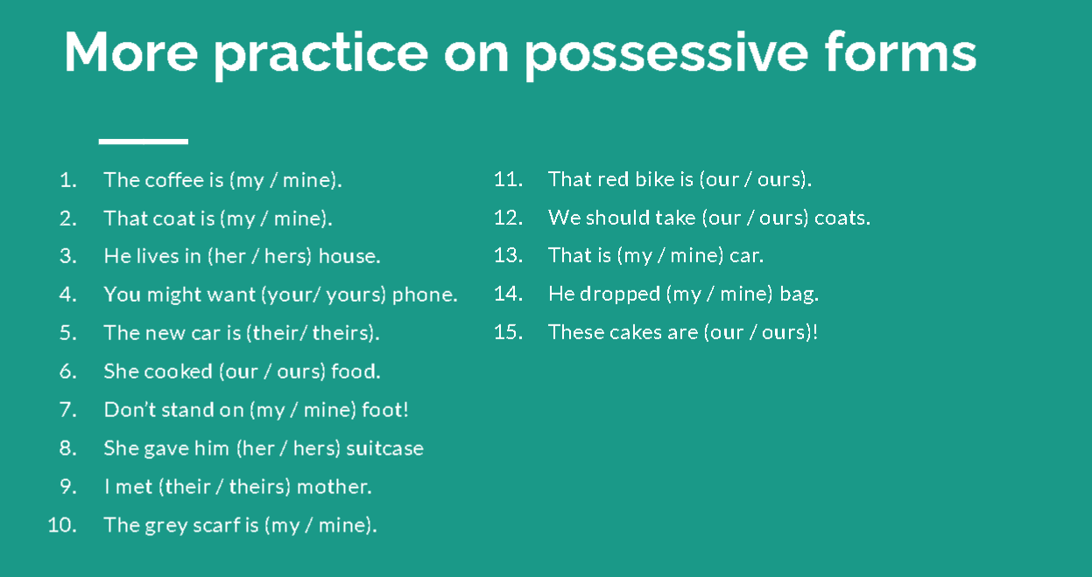
The Verb “to be”- Negative Form
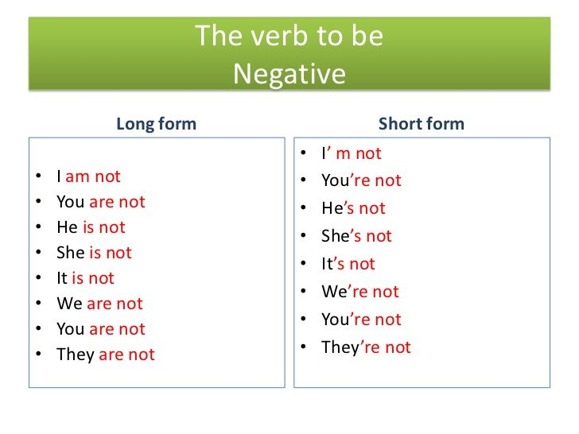
Activity: https://www.allthingsgrammar.com/uploads/2/3/2/9/23290220/atg-worksheet-beverbneg.pdf

Irregular Plural Nouns

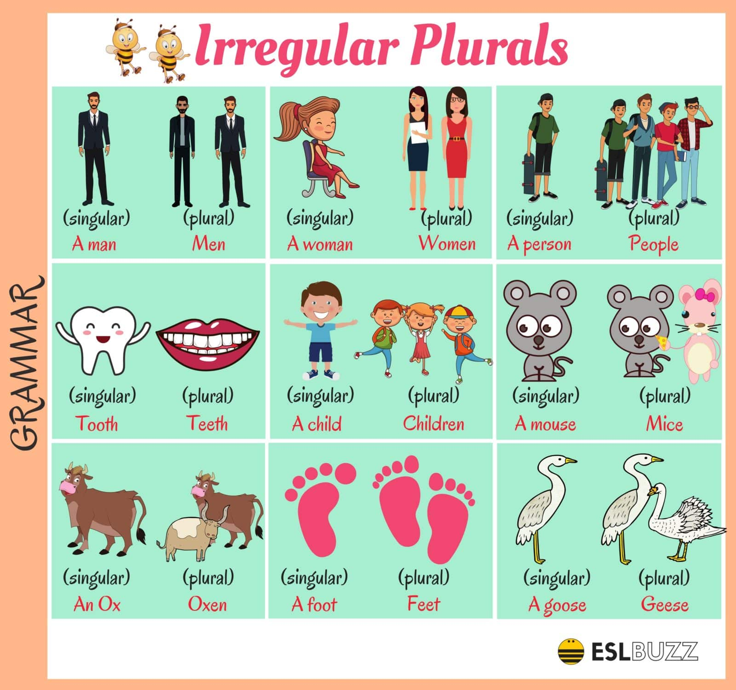

Activity
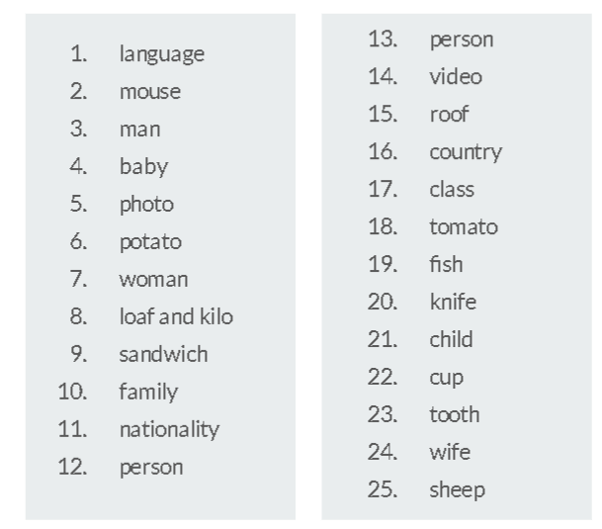
The Verb “to be” - Questions
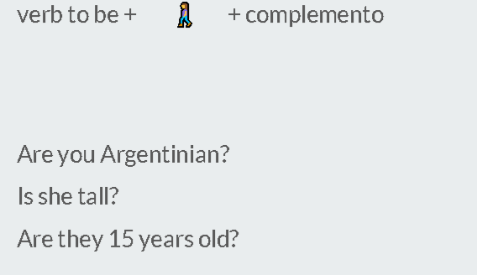
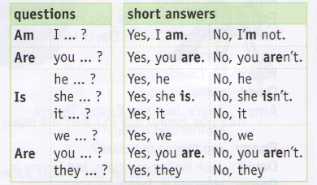
Activities:
https://en.islcollective.com/english-esl-worksheets/level/beginner-pre-a1/verb-be-affirmative-negative-interrogative/106363
http://www.iessuel.es/portal/attachments/article/200/03-BE.pdf

